**ASSIGNMENT 5-SIMPLE RESPONSIVE WEBSITE USING BOOTSTRAP**

**HOME PAGE CODING:**

<!DOCTYPE html>

<html lang="en">

<head>

    <meta charset="UTF-8">

    <meta name="viewport" content="width=device-width, initial-scale=1.0">

    <link href="https://cdn.jsdelivr.net/npm/bootstrap@5.0.2/dist/css/bootstrap.min.css" rel="stylesheet" integrity="sha384-EVSTQN3/azprG1Anm3QDgpJLIm9Nao0Yz1ztcQTwFspd3yD65VohhpuuCOmLASjC" crossorigin="anonymous">

    <script src="https://cdn.jsdelivr.net/npm/@popperjs/core@2.9.2/dist/umd/popper.min.js" integrity="sha384-IQsoLXl5PILFhosVNubq5LC7Qb9DXgDA9i+tQ8Zj3iwWAwPtgFTxbJ8NT4GN1R8p" crossorigin="anonymous"></script>

    <script src="https://cdn.jsdelivr.net/npm/bootstrap@5.0.2/dist/js/bootstrap.min.js" integrity="sha384-cVKIPhGWiC2Al4u+LWgxfKTRIcfu0JTxR+EQDz/bgldoEyl4H0zUF0QKbrJ0EcQF" crossorigin="anonymous"></script>

    <link rel="stylesheet" href="https://fonts.googleapis.com/css2?family=Material+Symbols+Outlined:opsz,wght,FILL,GRAD@20..48,100..700,0..1,-50..200&icon_names=menu" />

    <link rel="stylesheet" href="/AS5style.css">

    <title>PORTFOLIO</title>

</head>

<body>

  <div class="container-fluid">

    <nav class="navbar navbar-expand-lg bg-body-tertiary navbar-dark bg-dark">

  <div class="container-fluid">

    <a class="navbar-brand" href="#">PORT<span style="color:deeppink">FOLIO</a>

    <button class="navbar-toggler" type="button" data-bs-toggle="collapse" data-bs-target="#navbarSupportedContent" aria-controls="navbarSupportedContent" aria-expanded="false" aria-label="Toggle navigation">

      <span class="navbar-toggler-icon"></span>

    </button>

    <div class="collapse navbar-collapse" id="navbarSupportedContent">

      <ul class="navbar-nav ms-auto mb-2 mb-lg-0">

        <li class="nav-item">

          <a class="nav-link m-1" href="#">HOME</a>

        </li>

        <li class="nav-item">

          <a class="nav-link m-1" href="about me1.html">ABOUT</a>

        </li>

        <li class="nav-item">

          <a class="nav-link m-1" href="project1.html">PROJECT</a>

        </li>

         <li class="nav-item">

          <a class="nav-link m-1" href="contact1.html">CONTACT</a>

        </li>

        <li class="nav-item">

          <a class="nav-link m-1" href="navcard.html">NAV CARDS</a>

        </li>

       </div>

  </div>

    </nav>

  <section>

    <div>

      <h1 align="center">WELCOME</h1>

      <p>Sit back relax and explore some amazing portfolio!</p>

    </div>

  </section>

  </div>

  </body>

</html>

**STYLE CSS CODING:**

@import url('https://fonts.googleapis.com/css2?family=Goldman:wght@400;700&family=Gotu&family=Lobster&family=Poppins:ital,wght@0,100;0,200;0,300;0,400;0,500;0,600;0,700;0,800;0,900;1,100;1,200;1,300;1,400;1,500;1,600;1,700;1,800;1,900&family=Roboto:ital,wght@0,100..900;1,100..900&display=swap');

*{

    margin: 0;

    padding: 0;

    box-sizing: border-box;

}

body{

    font-family: "Roboto", sans-serif;

}

nav{

    width: 100%;

    position: sticky;

    top: 0;

    left: 0;

    box-shadow: 0px 5px 8px rgba(0, 0, 0,.5);

}

.navbar-brand{

    font-weight: 800;

    font-size: 25px;

    border-radius: 50px;

}

.navbar-nav a{

    color: white !important;

    background-color:violet;

    border-radius: 50px;

}

.navbar-nav a:hover{

    background-color: whitesmoke;

    color: black !important;

    border-radius: 5px;

}

section{

    background-image:url(https://files.123freevectors.com/wp-content/original/119530-pink-abstract-background-design.jpg);

    background-size: 50%;

    display: flex;

    align-items: center;

    height:100vh;

}

div h1{

    font-size: 90px;

    color:aquamarine;

    align-items: center;

    margin:auto;

**Navbar Using Portfolio and Hero Section:**

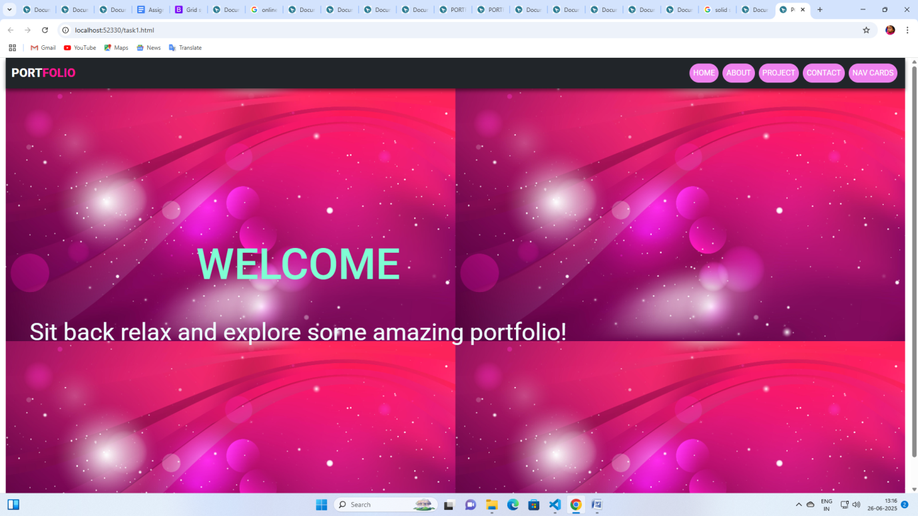

**ABOUT PAGE CODING:**

<!DOCTYPE html>

<html lang="en">

<head>

    <meta charset="UTF-8">

    <meta name="viewport" content="width=device-width, initial-scale=1.0">

    <title>Document</title>

    <link href="https://cdn.jsdelivr.net/npm/bootstrap@5.0.2/dist/css/bootstrap.min.css" rel="stylesheet" integrity="sha384-EVSTQN3/azprG1Anm3QDgpJLIm9Nao0Yz1ztcQTwFspd3yD65VohhpuuCOmLASjC" crossorigin="anonymous">

    <script src="https://cdn.jsdelivr.net/npm/@popperjs/core@2.9.2/dist/umd/popper.min.js" integrity="sha384-IQsoLXl5PILFhosVNubq5LC7Qb9DXgDA9i+tQ8Zj3iwWAwPtgFTxbJ8NT4GN1R8p" crossorigin="anonymous"></script>

<script src="https://cdn.jsdelivr.net/npm/bootstrap@5.0.2/dist/js/bootstrap.min.js" integrity="sha384-cVKIPhGWiC2Al4u+LWgxfKTRIcfu0JTxR+EQDz/bgldoEyl4H0zUF0QKbrJ0EcQF" crossorigin="anonymous"></script>

<style>

  body{

    border:10px solid gray;

    border-radius: 50px;

  }

  h1{

    background-color: orange;

    color:green;

  }

  div{

  display:grid;

    grid-template-columns: 1fr;

  }

  .para{

    display:flex;

    width:80%;

    height:70%

    font-weight:900;

  }

  .photo{

    height:80%;

    width:50%;

    margin-left: 40px;

  }

</style>

</head>

<body>

    <div class="container">

    <div class="row">

    <h1 align="center">ABOUT ME</h1>

       <div class="col">

    <img class="photo" style="float:left" src="https://static.vecteezy.com/system/resources/previews/024/966/233/non_2x/businesswoman-portrait-beautiful-woman-in-business-suit-employee-of-business-institution-in-uniform-lady-office-worker-woman-business-avatar-profile-picture-illustration-vector.jpg"alt="not found"height="200"width="300"/>

    </div>

    <div class="col">

    <p class="para">Hai, I am P.JEYA LAKSHMI.I am from Tirunelveli. I am completed my B.Sc., M.Sc., M.Phil.,I am working as a teacher past 7 years.My Technical skills are C,C++,HTML,CSS        and my personal attributes are discipiline and hard worker.I have a competative attitude and thrive under pressure.My confident is skillful and sincerly in all works and adjustable with

        everyone which helpful to teamwork.I am a hard-working and driven individual who isn't afraid to face a challenge. I'm passionate about my work and I know how to get the job done. I would describe myself as an open and honest person who doesn't believe in misleading other people and tries to be fair in everything I do.

        I’m very communicative, detail-oriented, and versatile. I like to think of myself as a team player. While I don’t mind taking on solo projects, I prefer to work with others.

        I’ve worked as a systems analyst since I graduated from college. I am very particular about the details of my work, but I also like to stay open-minded to new ideas. I never want to close myself off to other people’s opinions.

        I like to study new things. Being knowledgeable about (your field) or any subject is an ongoing process, and I’m always proactive about seeking new opportunities to develop and grow in my role. Those opportunities could be in the form of training, a conference, listening to a speaker, or taking on a new project, but the motivation is to increase my knowledge of the field.

      </p>

    </div>

  </div>

    </div>

</body>

</html>

**ABOUT PAGE USING BOOTSTRAP GRID TWO COLUMS:**

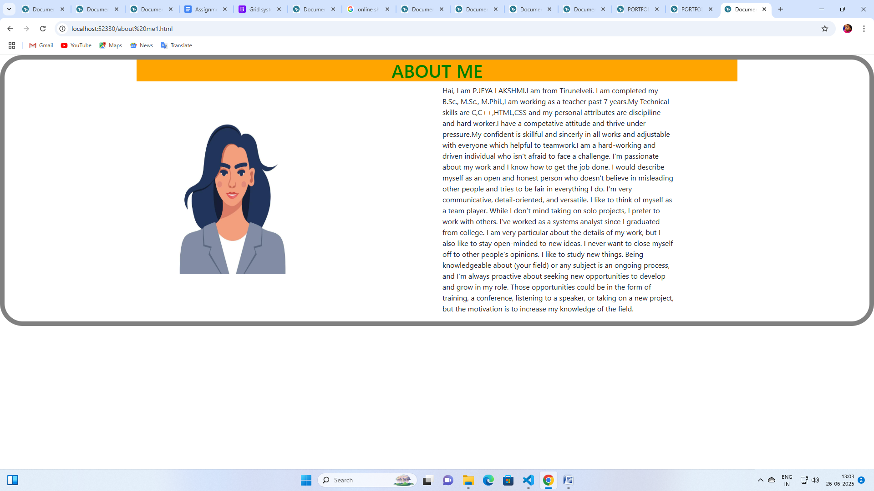

**PROJECT PAGE CODING:**

h<!DOCTYPE html>

<html lang="en">

<head>

    <meta charset="UTF-8">

    <meta name="viewport" content="width=device-width, initial-scale=1.0">

    <title>Document</title>

    <link href="https://cdn.jsdelivr.net/npm/bootstrap@5.0.2/dist/css/bootstrap.min.css" rel="stylesheet" integrity="sha384-EVSTQN3/azprG1Anm3QDgpJLIm9Nao0Yz1ztcQTwFspd3yD65VohhpuuCOmLASjC" crossorigin="anonymous">

    <script src="https://cdn.jsdelivr.net/npm/@popperjs/core@2.9.2/dist/umd/popper.min.js" integrity="sha384-IQsoLXl5PILFhosVNubq5LC7Qb9DXgDA9i+tQ8Zj3iwWAwPtgFTxbJ8NT4GN1R8p" crossorigin="anonymous"></script>

<script src="https://cdn.jsdelivr.net/npm/bootstrap@5.0.2/dist/js/bootstrap.min.js" integrity="sha384-cVKIPhGWiC2Al4u+LWgxfKTRIcfu0JTxR+EQDz/bgldoEyl4H0zUF0QKbrJ0EcQF" crossorigin="anonymous"></script>

<style>

        h1{

            color:brown;

        }

        .one{

            background-color:blue ;

        }

        .two

        {

            background-color:gold;

        }

        .three{

            background-color:orangered;

        }

        .four{

            background-color:green;

        }

        </style>

</head>

<body>

    <div class="container">

          <h1 align="center"><b><u>SOLID STATE PHYSICS</u></b></h1>

<div>

    <p class="one">Investigate different crystal growth techniques and their impact on the properties of the resulting crystals.</p>

<p class="two">Study the influence of temperature, solution concentration, and other parameters on the shape, size, and quality of crystals grown from solutions or melts.</p>.

<p class="three">Investigate the growth of materials with unique crystal structures, such as perovskites, garnets, or zeolites, and characterize their properties.

</p>

<p class="four">Frictional electricity is the electricity produced by rubbing two suitable bodies

and transfer of electrons from one body to other.Electrons in glass are loosely bound in it than the electrons in silk.

 </p>

</div>

 <img src="https://media.gettyimages.com/id/2179694965/vector/perovskite-molecule-illustration.jpg?s=612x612&w=gi&k=20&c=yK8CRgqegHZFKhT8yCw6dDgbBK1w_MaN1WVUkhaHwz4="alt="not found"height="300"width="300"/>

 <img src="https://img.brainkart.com/article/articlemYPcMelectro.png"alt="not found"width="300" height="300"/>

</body>

</html>

**Project output:**

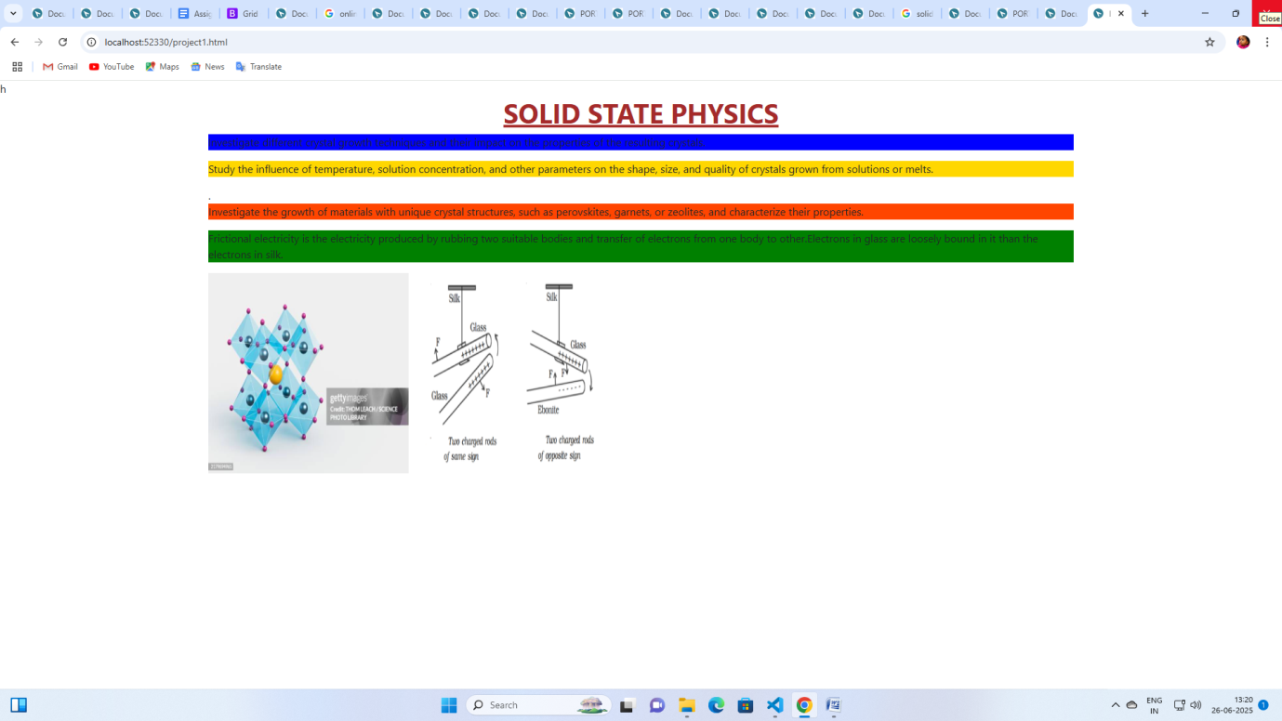

**CONTACT PAGE:**

<!DOCTYPE html>

<html lang="en">

<head>

    <meta charset="UTF-8">

    <meta name="viewport" content="width=device-width, initial-scale=1.0">

    <title>Document</title>

    <link href="https://cdn.jsdelivr.net/npm/bootstrap@5.0.2/dist/css/bootstrap.min.css" rel="stylesheet" integrity="sha384-EVSTQN3/azprG1Anm3QDgpJLIm9Nao0Yz1ztcQTwFspd3yD65VohhpuuCOmLASjC" crossorigin="anonymous">

    <script src="https://cdn.jsdelivr.net/npm/@popperjs/core@2.9.2/dist/umd/popper.min.js" integrity="sha384-IQsoLXl5PILFhosVNubq5LC7Qb9DXgDA9i+tQ8Zj3iwWAwPtgFTxbJ8NT4GN1R8p" crossorigin="anonymous"></script>

<script src="https://cdn.jsdelivr.net/npm/bootstrap@5.0.2/dist/js/bootstrap.min.js" integrity="sha384-cVKIPhGWiC2Al4u+LWgxfKTRIcfu0JTxR+EQDz/bgldoEyl4H0zUF0QKbrJ0EcQF" crossorigin="anonymous"></script>

 <style>

        table{

            border:1px solid black;

            width:400px;

            height: 500px;

            margin:auto;

            border-color:darkmagenta;

                }

        caption{

            color:greenyellow;

            font-size: 35px;

        }

        td{

            padding:30px;

            font-size: 25px;

            color:beige;

        }

        tr{

            background-color: blueviolet;

        }

        button:hover{

            background-color:orangered;

        }

    </style>

</head>

<body>

    <div class="container">

       <form>

       <table border="1">

            <tr>

                <td><label>Name:</label></td>

                <td><input type="text"name="name"value=""required/></td>

            </tr>

            <tr>

                <td><label>email</label></td>

                <td><input type="email"name="email"value=""required/></td>

            </tr>

            <tr>

                <td><label>subject</label></td>

                <td><select>

                    <option>Tamil</option>

                    <option>English</option>

                    <option>Mathematics</option>

                    <option>Physics</option>

                    <option>Chemistry</option>

                    <option>History</option>

                    <option>Economics</option>

                    <Option>Commerce</Option>

                </select></td>

            </tr>

            <tr>

                <td><label>message</label></td>

                <td><textarea required>I am jeyalakshmi.I am coming from tvl.</textarea></td>

            </tr>

            <tr>

                <td colspan="4"><button type="submit">Register</button></td>

            </tr>

        </table>

       </form>

    </div>

</body>

</html>

**Output:**

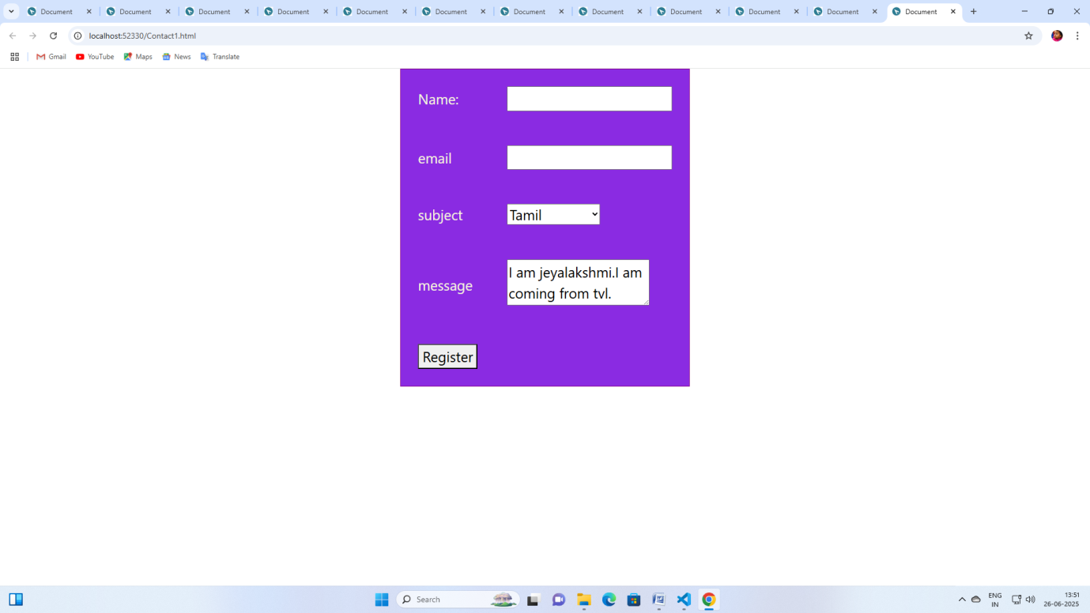

**NAVBAR CARDS CODING:**

<!DOCTYPE html>

<html lang="en">

<head>

    <meta charset="UTF-8">

    <meta name="viewport" content="width=device-width, initial-scale=1.0">

    <title>Document</title>

    <link href="https://cdn.jsdelivr.net/npm/bootstrap@5.0.2/dist/css/bootstrap.min.css" rel="stylesheet" integrity="sha384-EVSTQN3/azprG1Anm3QDgpJLIm9Nao0Yz1ztcQTwFspd3yD65VohhpuuCOmLASjC" crossorigin="anonymous">

    <script src="https://cdn.jsdelivr.net/npm/@popperjs/core@2.9.2/dist/umd/popper.min.js" integrity="sha384-IQsoLXl5PILFhosVNubq5LC7Qb9DXgDA9i+tQ8Zj3iwWAwPtgFTxbJ8NT4GN1R8p" crossorigin="anonymous"></script>

<script src="https://cdn.jsdelivr.net/npm/bootstrap@5.0.2/dist/js/bootstrap.min.js" integrity="sha384-cVKIPhGWiC2Al4u+LWgxfKTRIcfu0JTxR+EQDz/bgldoEyl4H0zUF0QKbrJ0EcQF" crossorigin="anonymous"></script>

</head>

<body>

  <div class="container-fluid">

    <div class="card" style="width: 18rem;">

  <img src="https://img.freepik.com/premium-photo/online-fashion-shopping-with-computer_23-2150400628.jpg?semt=ais_hybrid&w=740" class="card-img-top" alt="...">

  <div class="card-body">

    <h5 class="card-title">Card title</h5>

    <p class="card-text">Some quick example text to build on the card title and make up the bulk of the card's content.</p>

    <a href="#" class="btn btn-primary">Go somewhere</a>

  </div>

</div>

  </div>

</body>

</html>

**NAVCARD USING BOOTSTRAP GRID SYSTEM USING 3 DIFFERENT SCREEN SIZES:**

**CONTAINER-FLUID USING MOBILE SCREEN UPTO 768PX:**

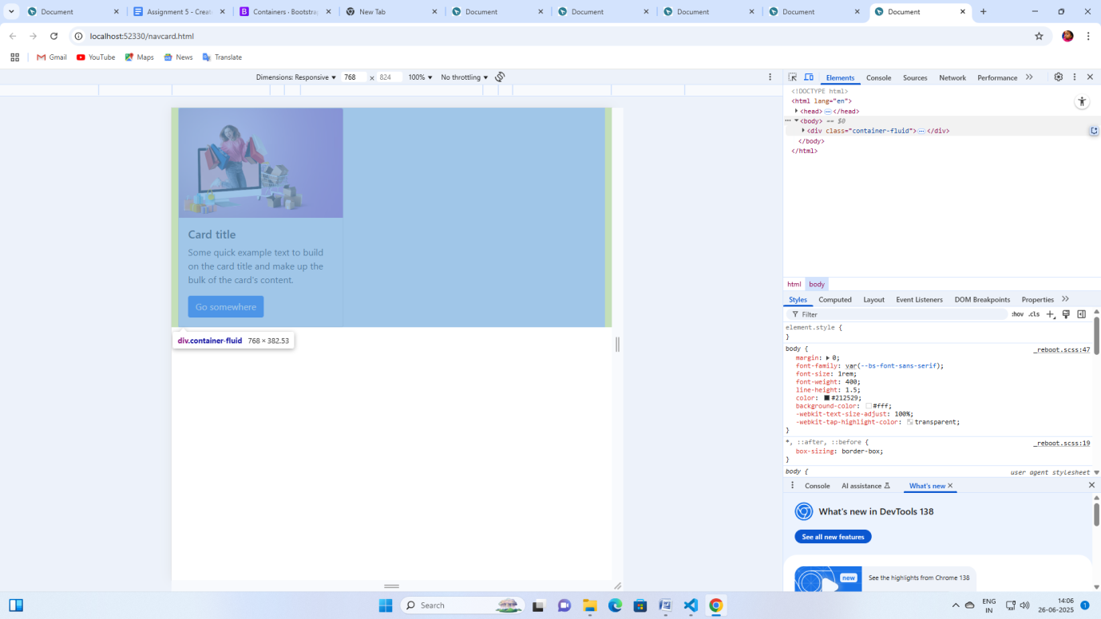

**TABLET SCREEN 1024PX USING CONTAINER-FLUID 100% VIEW:**

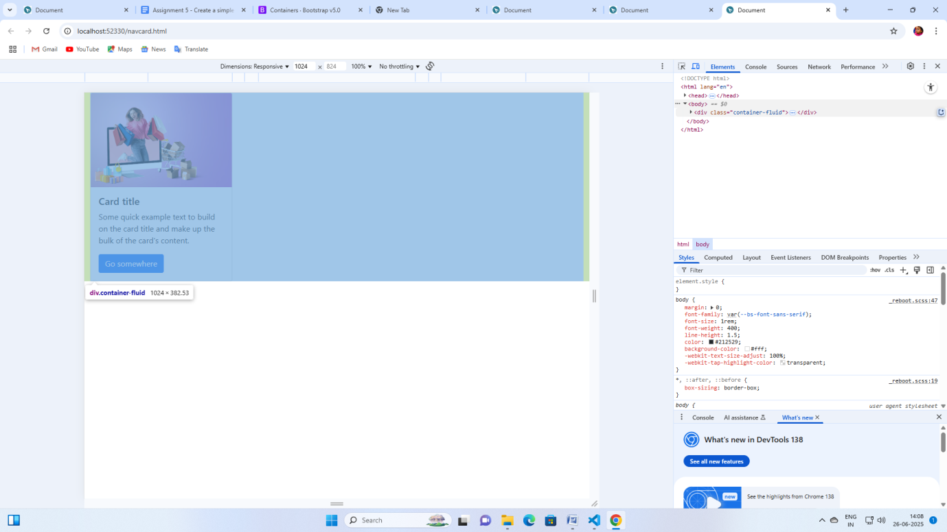

**DESKTOP SCREEN ABOVE 1024PX ALSO FULL 100% VIEW USING CONTAINER-FLUID:**

